2025

Rhea Jugernath, Erin Naidoo, Shiara Phekoo, Chloe Naidoo

404 Solutions

20/04/2025

404 Solutions -Part 1 – Planning and Design



**Table of Contents**

Introduction 2

Brief Overview of the App 2

Requirements List 3

User Interface Design 6

Project Plan 8

Conclusion 10

Reference List 11

# Introduction

This project aims to create a budgeting app that allows users to easily manage their expenses and finances while giving them a pleasant user experience. The app requirements will be listed and elaborated on below detailing every page and all functionality that will be implemented onto each of them. A project plan showing the scope and timeline of this project will also be provided specifying who in the team is assigned to which task, the completion status of the task, the date of which the task is expected to begin and be completed by. A user interface design of how we plan to design the app with descriptions of each screen and a graphical representation of the navigation from screen to screen will also be provided. All of these parts put together make up our thorough and detailed design plan for the development of our unique budgeting app. (Indeed, Editorial Team, 2024)

# Brief Overview of the App

Our app that we will create is Smart Spend, a budgeting app that is designed to allow users to easily and efficiently manage their finances and budget seamlessly by tracking incomes and expenses and achieve their financial goals. The logo we have designed fits our app perfectly with a business line graph that shows users they can expect improvements in their finances with the use of our app. It is sleek, professional and matches with the colour scheme and theme of the rest of the app’s interfaces. Our app is ideal for anyone in need of budgeting assistance ranging from teenagers to the elderly. It will have a user-friendly interface that is easy to understand and use, making it a good, suitable choice for our target audience range. The app will be created, coded and tested in Android Studio using the Model-View Controller (MVC) architecture and our storage databases will be created and stored securely in SQL Server Management Studio.

Smart Spend is unique because we have taken our previous research and comparisons noted in our research document between the budgeting apps, namely Goodbudget, Monefy and PocketGuard, into consideration when designing our own app to make sure we include the best features of these apps while improving on their shortcomings to build our own unique, innovative, efficient and robust budgeting app. What makes Smart Spend special as compared to existing budgeting apps is our reward feature. We have included a gamification feature that is our Daily Star Reward Pop-Up that awards users a star for every day they log in to the app consecutively. This will give users a sense of achievement and motivate them to regularly make use of the app which increases the overall engagement. Our app has an array of automatically generated trend graphs to give users a graphical representation of their monthly spending per category and the status of their budgeting goals. We also provide users with a log for their expenses and income which can assist in keeping track of where their money is going or coming in from. These are just some of the innovative features our app includes, the rest will be included and discussed in further detail below. (Indeed, Editorial Team, 2024)

# Requirements List

**(DashDevs ,2025)**

2.1 Login Page

* Username (User Input)
* Password (User Input)
* Login Button
* An option to signup if the user is new
* Logo displayed on each page throughout the application

2.2 Signup Page

* Username (User Input)
* Email address (User Input)
* Password (User Input)
* Sign Up Button

2.3 Home Page

* Displaying Account Balance
* Nav Bar (Hover Button):
  + Each page name (links to respective pages)
  + Available on all pages except Login, Sign up pages
* Total Expense button (navigates Total Expenses page, result displayed on button)
* Total Income button (navigates to Total Incomes page, result displayed on button)
* Total Transactions button (navigates to Total Transactions page, result displayed on button)
* Large New Expense button (navigates to New Expense page)
* Large New Income button (navigates to New Income page)
* Gamification Elements (pop up):
  + Reward system for Loging in (more days logged in the more achievements)

2.4 New Expense Page

* Date (calendar dropdown)
* Amount (user input for expense amount)
* Category (dropdown menu displaying categories)
* Description (text input for expense description)
* Upload (file upload button for proof of expense)
* Add button (to submit expenses)

2.5 New Income Page

* Date (calendar dropdown)
* Amount (user input for income amount)
* Category (dropdown menu displaying categories)
* Description (text input for income description)
* Add button (to submit income details)

2.6 Total Expenses Page

* Display each expense entry
* Each expense must be clickable to show uploaded details
* Each expense entry must display:
  + Expense Name
  + Date
  + Amount

2.7 Total Incomes Page

* Display each income entry
* Each income must be clickable to show uploaded details
* Each income entry must display:
  + Income Name
  + Date
  + Amount

2.8 Total Transactions Page

* List of all transactions
* Display each Income and its amount
* Display each Expense and its amount

2.9 Categories Page

* Display list of categories
* View total expenses per category when a category is clicked
* Set Monthly Budget Goal per category
* Set Time Limit for category budgets
* Graphical Representation:
  + Graph showing daily spending trends
  + Identify spending patterns

2.10 Progress Dashboard

* Display Budget Spent for each month
* Display Budget/Goal set for each month

3. Technical Requirements with possible solutions

* Frontend: React, Vue.js, or Angular
* Backend: Node.js, Django, or Laravel
* Database: PostgreSQL, MongoDB, or Firebase
* Hosting: AWS, Digital Ocean, or Firebase
* APIs: Open Banking API (if financial data integration is needed)

4. Security Requirements

* Data Encryption: SSL/TLS for secure data transfer
* Authentication & Authorization: OAuth 2.0, JWT, or biometric login
* Compliance: GDPR, CCPA for data privacy
* Backup & Recovery: Automatic backups
* Audit Logs: Track login attempts and changes

5. Non-Functional Requirements

* Scalability: Support multiple users without performance loss
* Usability: Intuitive UI/UX for all user types
* Performance: Fast loading times and optimized queries
* Cross-Platform Compatibility: Mobile and desktop responsiveness

# User Interface Design

Figma User Interface Diagram Link : <https://www.figma.com/board/BAPdOSdlzBF8ycuil1xgkW/PROG7313-UI-Diagram?node-id=0-1&t=V1dC2w9BW7zjtniB-1>

Canva Diagram Link: <https://www.canva.com/design/DAGhm1aGdwA/bbqd3AuSogMTm8bBWiRHiA/edit?utm_content=DAGhm1aGdwA&utm_campaign=designshare&utm_medium=link2&utm_source=sharebutton>

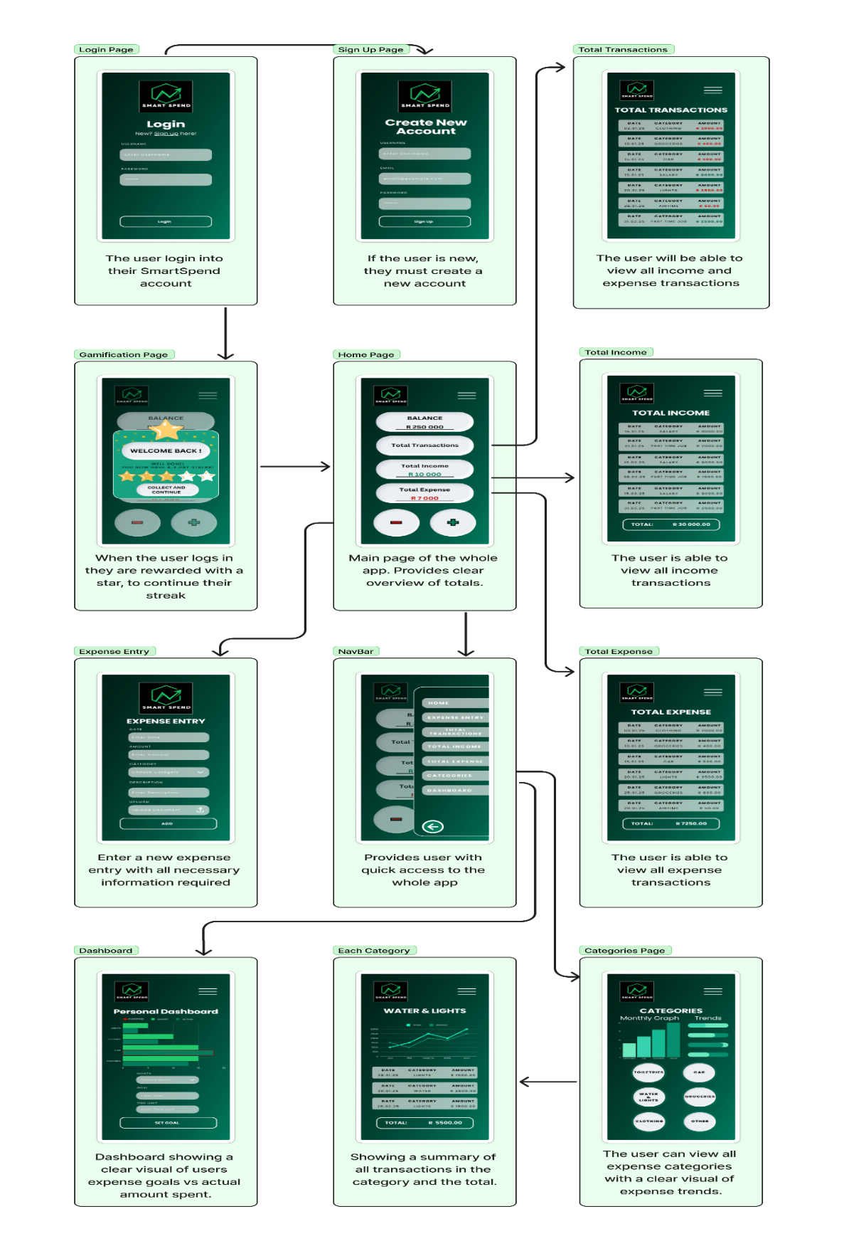

(Figma,2025)

# Project Plan

(Rahul Awati, 2024)

# 

# Conclusion

In this document we have revised our overall intent and reasoning behind why we decided to create the app, to provide users with a budgeting app that fulfills all their possible needs from tracking their income and spending, setting budgeting goals and giving representative feedback on their budgeting for the month. In the previous document we conducted our research into three top-ranking budgeting apps in the app store that is available for android users and found their best features, features that they lack and compared each app. All this research was considered when designing Smart Spend. In this document we have explained in detail all the functionalities we plan to include in the app in the app requirements list, the scope, timeline and assignment of tasks in the project plan and the app user interfaces. All this planning put into action will result in Smart Spend, our professional, efficient and innovative budgeting app. (Indeed, Editorial Team, 2024)

# 

# Reference List

* **Awati, R. (2024)** *Project planning: What it is and 5 steps to create a plan* [Online]. Available at[: https://www.techtarget.com/searchcio/definition/project-planning](https://d.docs.live.net/43B6EEAD7690B636/Documents/:%20https:/www.techtarget.com/searchcio/definition/project-planning) (Accessed: 14 March 2025).
* **Canva (2025)** *PROG7313 UI* [Online]. Available at: <https://www.canva.com/design/DAGhm1aGdwA/bbqd3AuSogMTm8bBWiRHiA/edit?utm_content=DAGhm1aGdwA&utm_campaign=designshare&utm_medium=link2&utm_source=sharebutton> (Accessed: 18 March 2025).
* **DashDevs (2025)** *How to write good software requirements specification for your mobile application* [Online]. Available at: <https://dashdevs.com/blog/how-to-write-good-software-requirements-specification-for-your-mobile-application/> (Accessed: 19 March 2025).
* **Figma (2025)** *Figma: the collaborative interface design tool* [Online]. Available at: <https://www.figma.com/board/BAPdOSdlzBF8ycuil1xgkW/PROG7313-UI-Diagram?node-id=0-1&t=V1dC2w9BW7zjtniB-1> (Accessed: 18 March 2025).
* **IIE Varsity College (2020)** *Module Manual/Guide 2025* [Online]. Available at: [https://advtechonline.sharepoint.com/...](https://advtechonline.sharepoint.com/:w:/r/sites/TertiaryStudents/_layouts/15/Doc.aspx?sourcedoc=%7BCD4184FB-DB29-43FB-8B04-0A6EE4B7987E%7D&file=PROG7313MM.docx&action=default&mobileredirect=true) (Accessed: 14 March 2025).
* **Indeed, Editorial Team (2024)** *Project Introductions: What They Are and How To Write Them* [Online]. Available at: <https://www.indeed.com/career-advice/career-development/project-introduction> (Accessed: 12 March 2025).
* **Indeed, Editorial Team (2024)** *How To Write a Project Overview in 5 Steps* [Online]. Available at: <https://www.indeed.com/career-advice/career-development/how-to-write-project-overview> (Accessed: 12 March 2025).
* **OpenAI (2025)** *ChatGPT [Artificial Intelligence chatbot]*. Available at: <https://chat.openai.com> (Accessed: 19 March 2025).